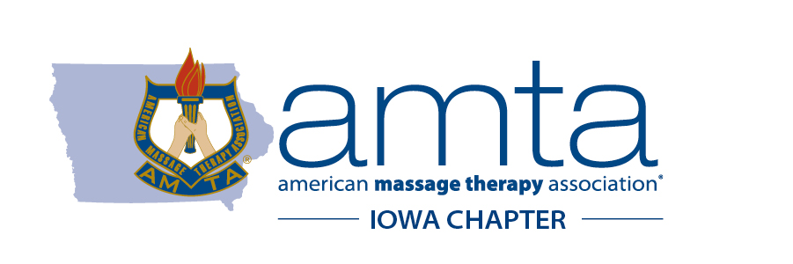
The American Massage Therapy Association (AMTA) is the largest non-profit, professional association serving massage therapists and massage therapy schools across the country. AMTA’s mission is to serve its members while advancing the art, science, and practice of massage therapy. For over 75 years, AMTA has advanced the massage therapy profession and fostered clinical research on its value and efficacy. AMTA has 51 active chapters, including the Iowa Chapter (AMTA, Iowa Chapter).
There are approximately 3,200 Licensed Massage Therapists (LMTs) in Iowa. These LMTs work in health care facilities like hospitals, hospices, and medical offices, as well as, on-site in homes, at sporting events, in corporate offices, in spa or salon settings, in private practices, in gyms or athletic team training centers, and in franchise massage therapy clinics. Massage therapy is a key component of treatment for thousands of patients facing chronic pain across the country and it also promotes overall health and wellness in our communities.
Iowa is one of 46 states that licenses massage therapists, and our law requires at least 600 hours of training from an approved program and passage of a national exam to become licensed. LMTs must also obtain 16 continuing education credits every two years to renew their license. State-level licensing ensures consumers that the massage therapists they see have met an educational and ethical standard to practice safely.
2021 LEGISLATIVE AGENDA

Empower Local Officials to Enforce State Laws
The 2017 General Assembly allowed cities to enact local ordinances against legitimate massage therapy businesses in an effort to combat human trafficking. Since that legislation passed, many cities have enacted new and widely varying ordinances against massage therapy businesses to address these issues they are having in their communities. The ordinances vary widely in scope and impact, forcing businesses to confront duplicate regulations that are creating confusion between existing state regulation and local ordinances. The goals of local human trafficking ordinances can be accomplished by simply empowering local officials to enforce state laws and regulations concurrently with state regulators.

Uphold the Integrity of Massage Therapy Licensing in Iowa
Licensure of massage therapists helps inform a consumer about the qualifications and competency of a massage therapist. Without licensing, it would be legal for anyone to offer massage therapy services. Iowa’s massage therapy licensing provisions have provided the state with a way to discourage and prevent illicit human trafficking practices from offering illegal services. By providing a legal definition of the scope of massage therapy practices, professional licensure helps consumers identify the responsibilities and services unique to a massage therapist. It allows consumers to select the most appropriate massage therapy professional for their needs and brings the benefit of open access to the selection process.

There are a number of other ways to improve professionalism within the industry as well as assist in the enforcement of illicit businesses through photo identification and mandatory reporting. Implementing these policies will help ensure accountability, improve public trust and safety in these providers while discouraging human trafficking activity under the massage therapy umbrella.

AMTA, Iowa Chapter requests the Iowa Legislature:
- Pass legislation granting local governments the power to enforce state laws and
regulations specific to massage therapy oversight
- Uphold the integrity of massage therapy licensure
- Require photo identification on licensure documents issued by the state board
- Require all licensed massage therapists to be mandatory reporters

AMTA, Iowa Chapter’s Government Relations Chair is Rachel Brown. She can be reached at legislationchair.amtaiowa@gmail.com.

