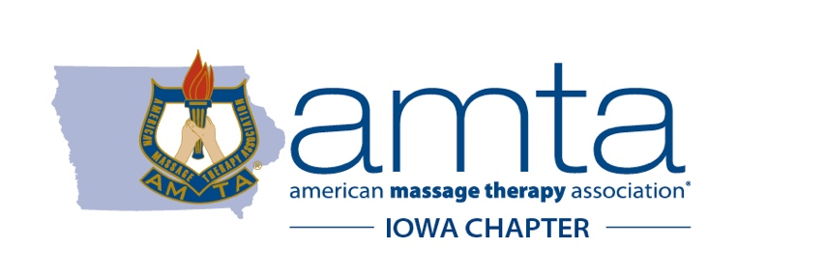
AMTA-IA 2020/2021 Legislative Session Timetable

Nov. 6 – Receive Election Update from Advocacy Strategies

Dec. 12 – Monthly AMTA Advocacy Call: 2021 Session Preview 9am

Jan. 8 – Receive Session Overview from Advocacy Strategies

Jan. 11 – First Day 2021 Legislative Session

Jan. 16 – Monthly AMTA Advocacy Call 9am

Feb. 2 – Tentative AMTA-IA Lobby Day at the Capitol
11:30am-1pm in Room 116

Feb. 12 – Final day for bill requests to the Legislative Services Agency

Feb. 13 – Monthly AMTA Advocacy Call 9am

March 5 – First Legislative Funnel Deadline

March 13 – Monthly AMTA Advocacy Call 9am

April 2 – Second Legislative Funnel Deadline

April 10 – Monthly AMTA Advocacy Call 9am

April 30 – Last Scheduled Day 2021 Legislative Session

Monthly AMTA Advocacy Call
Dial-in: (563) 999-1094
Access Code: 312263

